**Name:** Om Raut **Designation:** DevOps Engineer

**Task 3 Report: CI/CD Hello World using Jenkins**

**Objective**

To set up a basic **CI/CD pipeline** using **Jenkins** that demonstrates automated stages for **Build → Test → Deploy**.

**Environment Setup**

* **Platform:** AWS EC2 Instance (Ubuntu 22.04 LTS)
* **Tools Installed:**
  + Java 17 (OpenJDK)
  + Jenkins v2.516.2
  + Git
  + Docker (for later tasks)

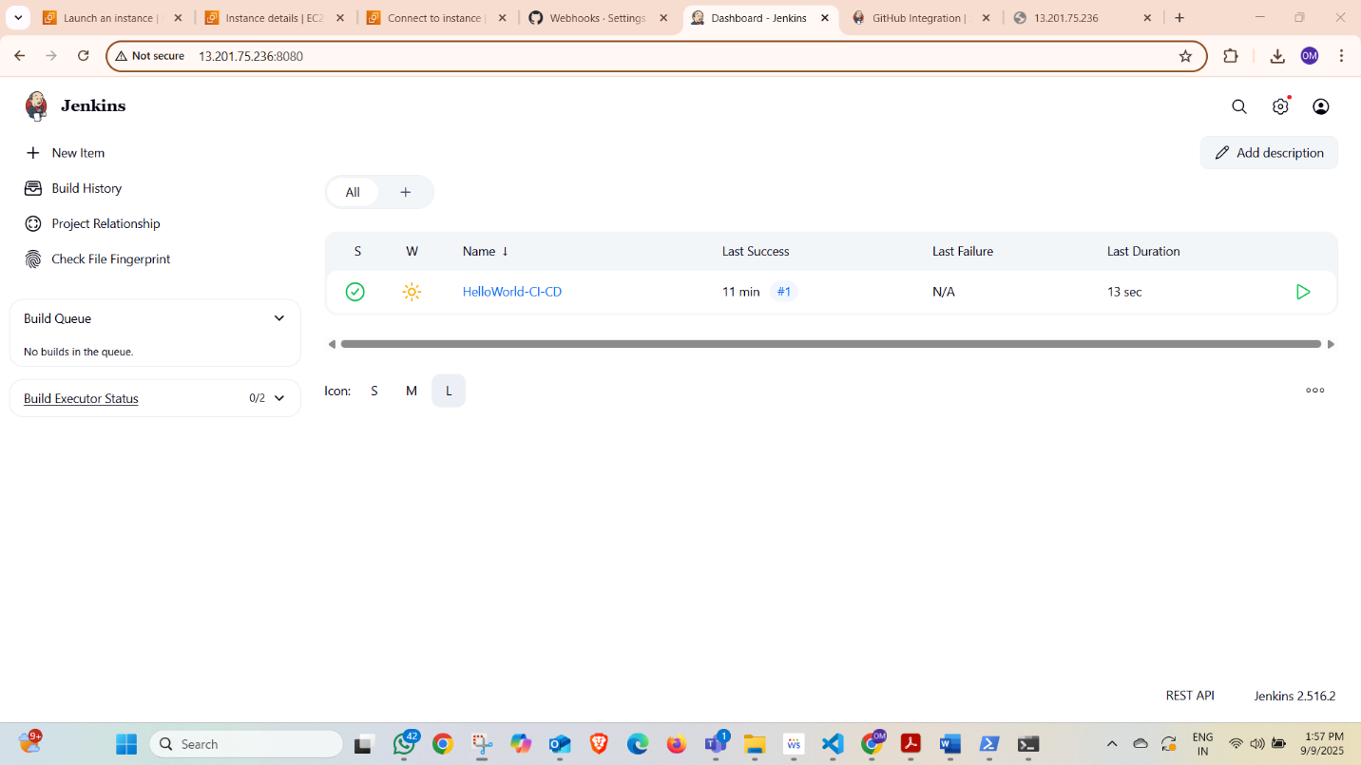

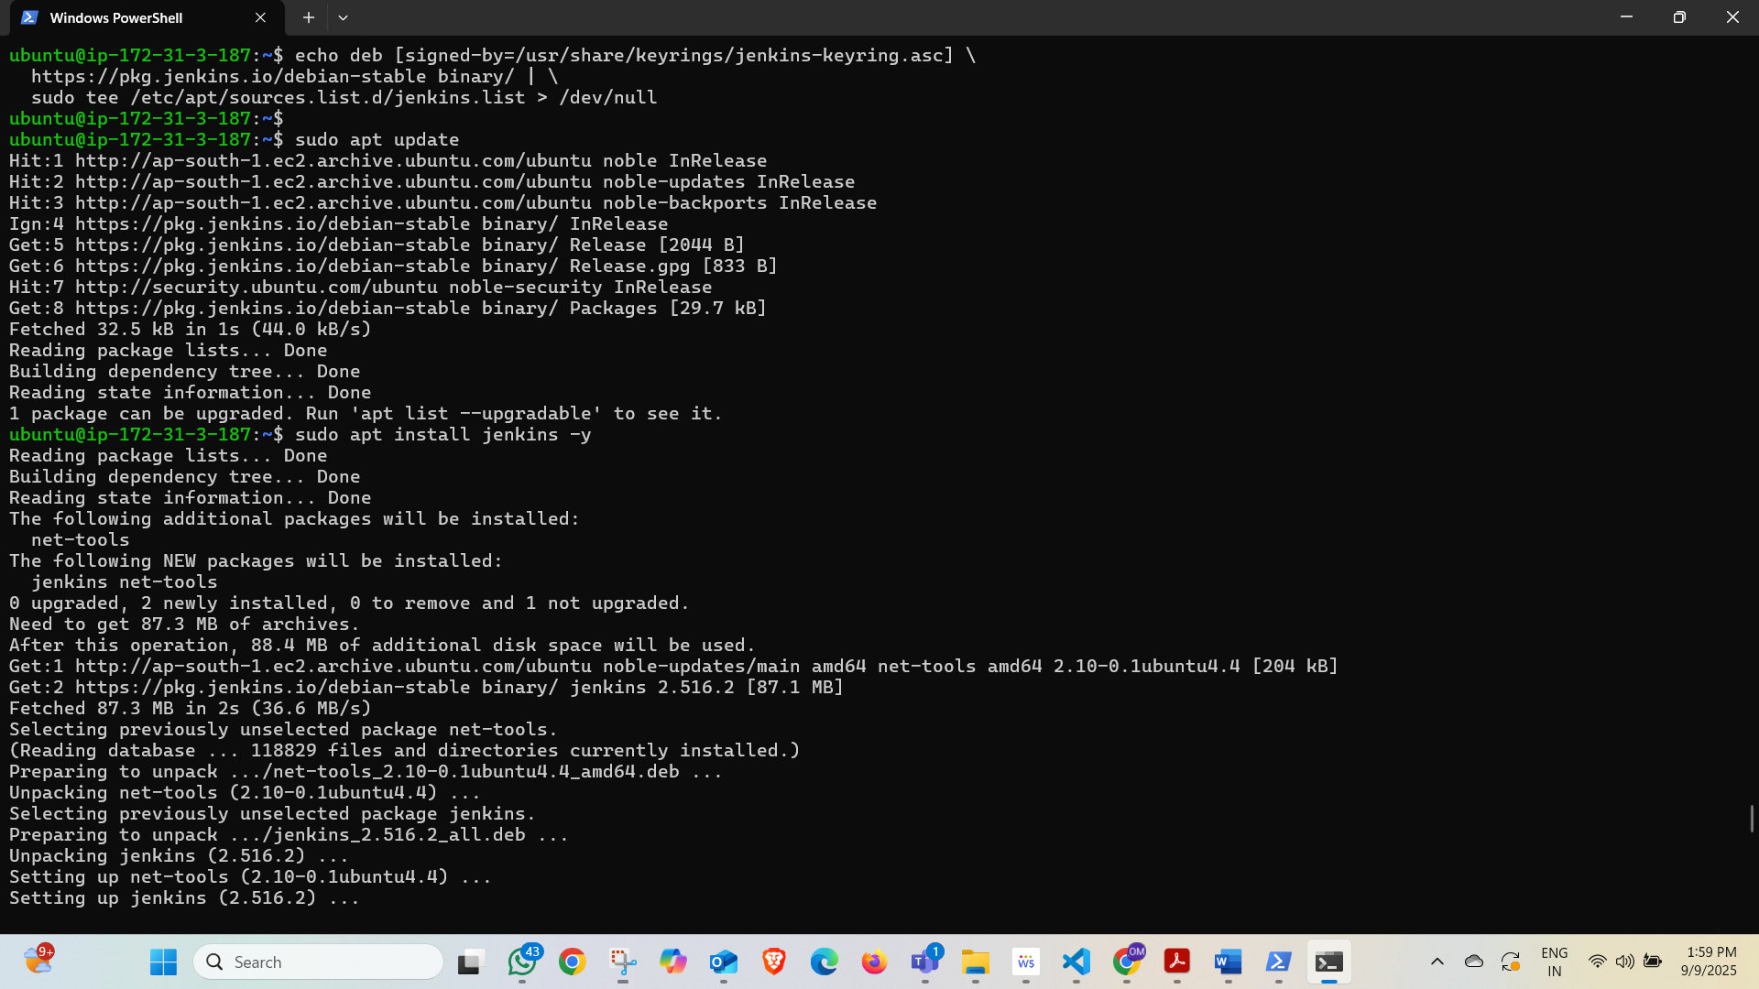

**Steps Performed**

**Step 1: Installed Jenkins**

* Added Jenkins repository and key.
* Installed Jenkins using apt.
* Verified service status.

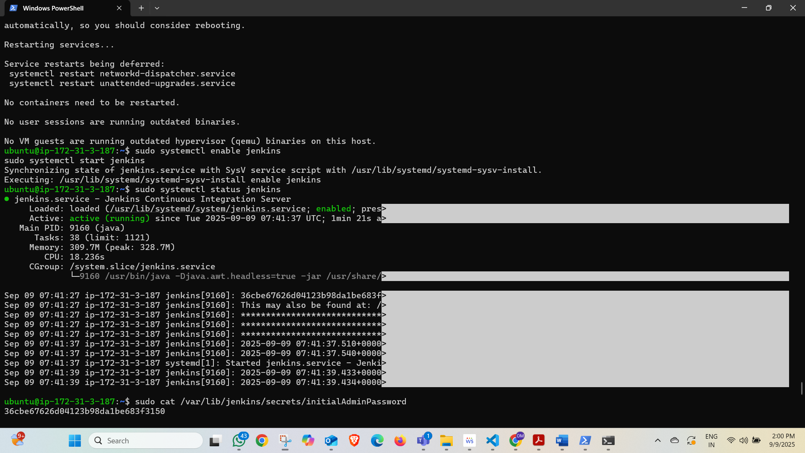

**Step 2: Jenkins Initial Setup**

* Unlocked Jenkins with /var/lib/jenkins/secrets/initialAdminPassword.
* Installed suggested plugins.
* Created admin user.

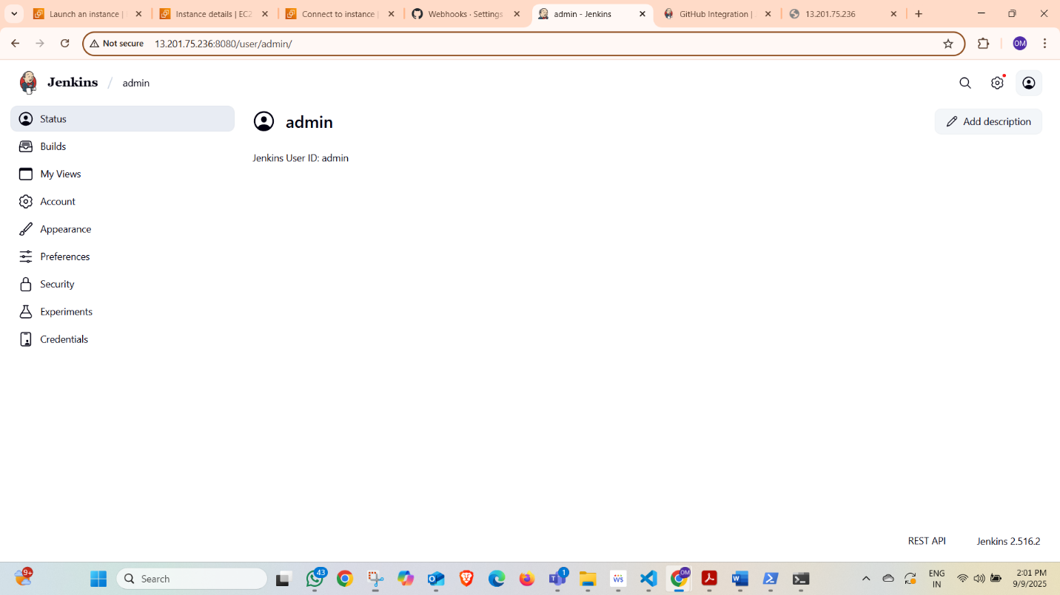

**Step 3: Created Pipeline Job**

* Created a new job → Selected **Pipeline** → Named it **HelloWorld-CI-CD**.
* Configured pipeline using a Jenkinsfile.

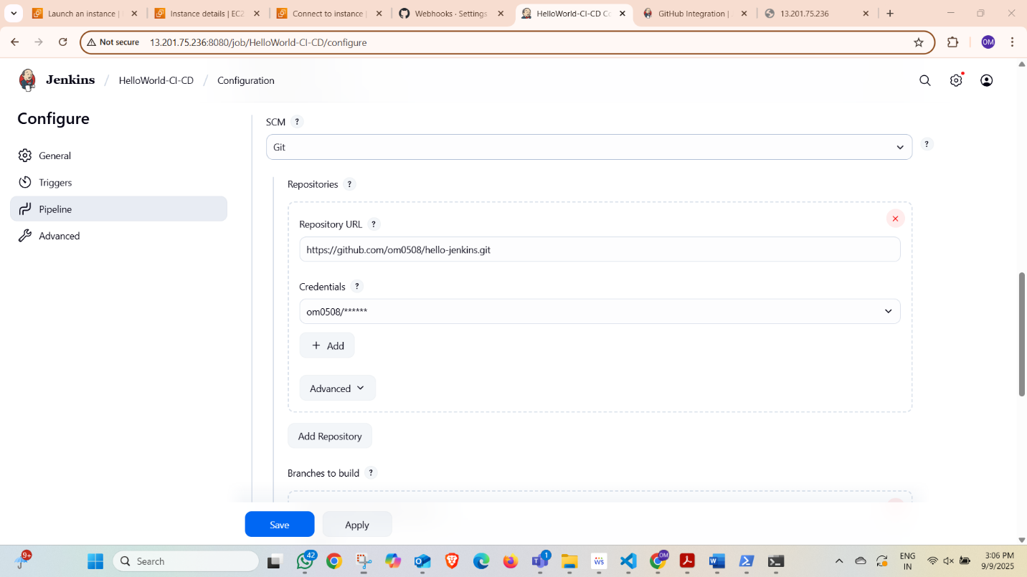

**Step 4: Jenkins file Code**

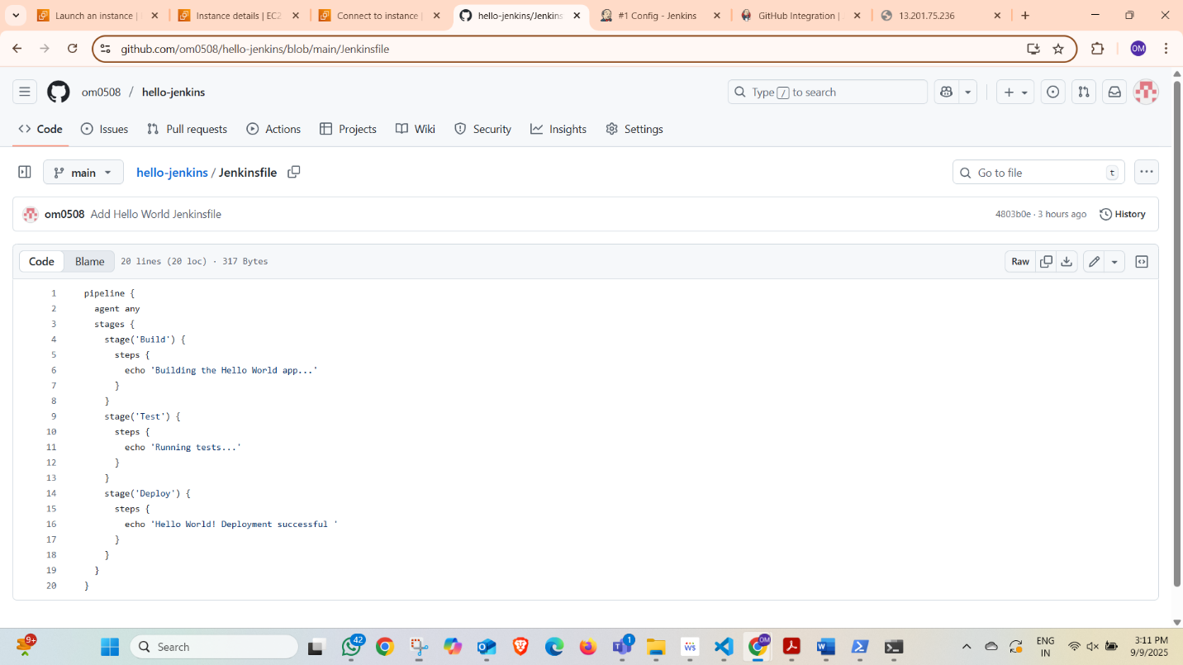

**Step 5: Execution**

* Clicked **Build Now** to run the pipeline.
* Observed console output showing all 3 stages.

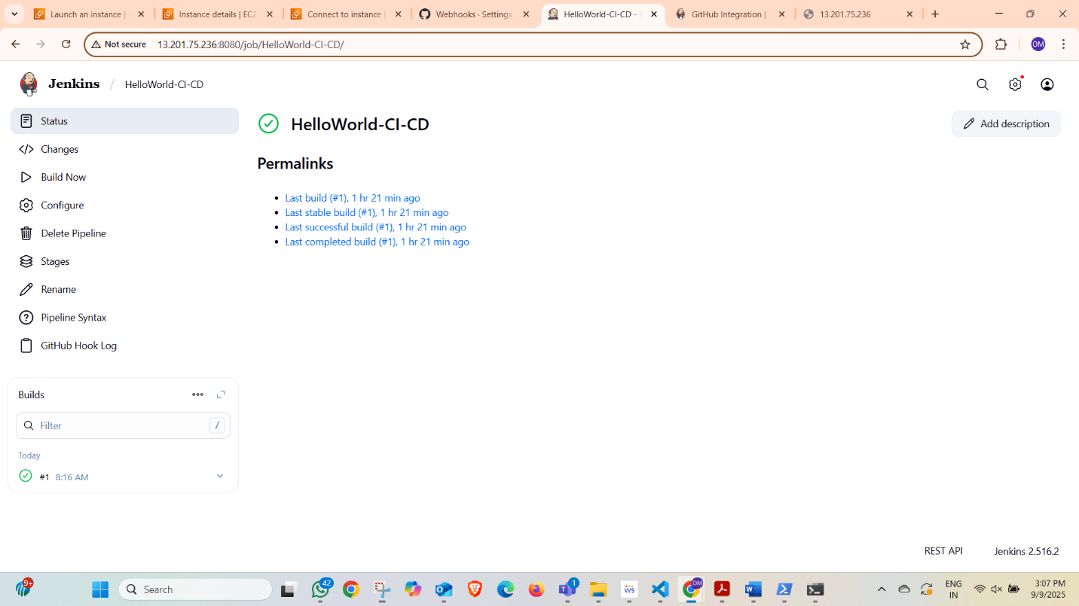

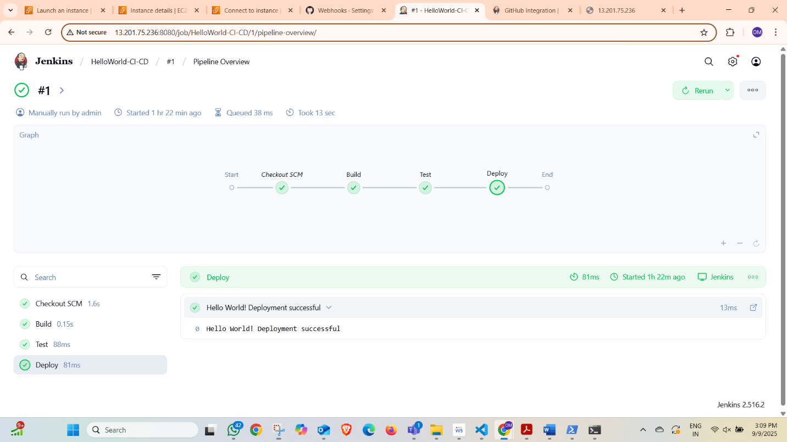

**Results**

* A **3-stage pipeline** (Build → Test → Deploy) was successfully implemented.
* Jenkins executed all stages sequentially.
* Output verified in Console.

**Conclusion**

The **Task 3 Hello World Pipeline** successfully demonstrated the **CI/CD flow in Jenkins**.  
This exercise provided a strong foundation for extending pipelines to real-world applications (e.g., Docker builds, GitHub integration, and Kubernetes deployments).